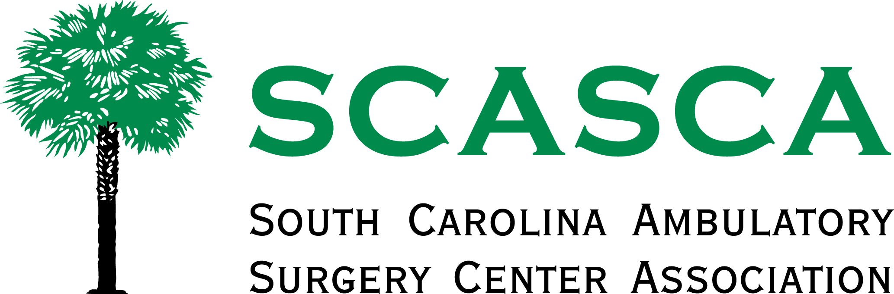
Welcome to the SCASCA Infection Control Seminar
Saturday, October 5, 2019
Wingate by Wyndham Columbia/Lexington
108 Saluda Pointe Courte
Lexington, SC 29072

Agenda
8:30 am Registration
9:00 am Decontamination and Safe Handling of Reusable Devices Arthur Henderson, Steris
Cleaning Challenges related to Biofilms
Steam Sterility Assurance Monitoring
11:30 am Lunch
12:00 pm Gaming Your Knowledge of Cleaning Arthur Henderson, Steris
and Decontamination Part 2
1:30 pm Adjourn

